What’s All the Buzz about

Black Seed Oil:

Benefits, where to find it, and how to use it

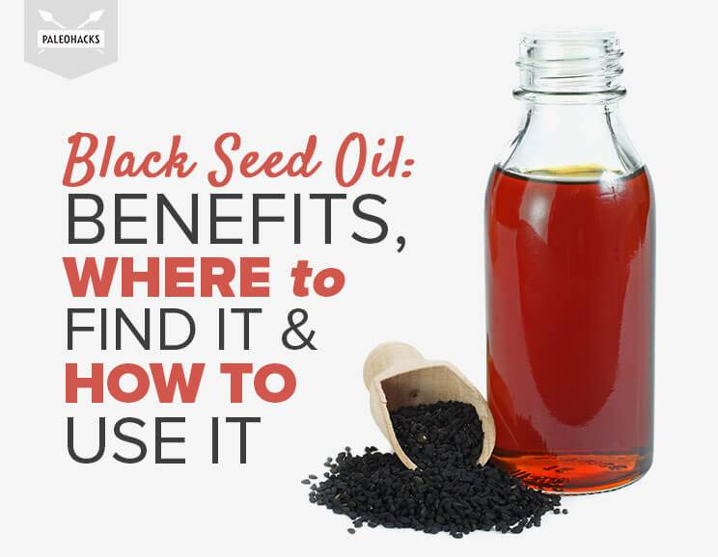
Today’s blog is republished from my friends at Paleohacks, a leading publisher of daily alternative health tips that I personally read every day. You can find the original article here…
By: Megan Patiry
Black seed oil, or Nigella Sativa, comes from the seeds of the Nigella Sativa plant. Native to Asia, historical accounts date the use of its seeds as far back as ancient Egypt.
Folklore from the surroundings regions, including Indian and Arabic civilizations, refer to the tiny seeds as “Habbatul barakah” (seed of blessing) for their ability to ease indigestion, treat asthma, bronchitis, rheumatism, diarrhea, and even energize the body and ease “dispiritedness” (1).
Today, these claims seem to withstand the tests of an impressive amount of present-day studies. Black seed oil’s main phytochemical compounds, thymoquinone, thymohydroquinone, and thymol, have been shown to have an astounding number of benefits, from being potent antifungals to possible contenders in the fight against Alzheimer’s and autism (2, 3).

Black Seed Oil Benefits
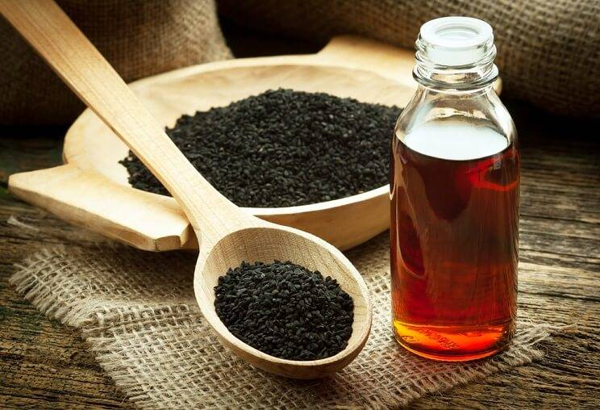
Below we’ll take a look at the top nine benefits of black seed oil, breaking down exactly why these little seeds hold so much power.

1. Black Seed Oil May Prevent Diabetes
Black seed oil shows huge promise when it comes to preventing and managing both type 1 and type 2 diabetes. One study out of the Indian Council of Medical Research found that black seed oil actually caused a partial “regeneration” of pancreatic cells, lowered previously elevated serum glucose levels, and lowered serum insulin concentrations (4).
In the same study, researchers also mentioned that black seeds improved glucose tolerance as well as the major type 2 diabetes drug metformin without the nasty side effects of stomach pain, bloating, headaches, heartburn, and flushing (5). Of course, you’ll want to speak to your doctor before quitting any medications.

2. Black Seed Oil Has Anti-Cancer Properties
If research has anything to say about black seed oil, it’s that it is a potent cancer cell fighter. Studies have shown its active compound, thymoquinone, reduces malignant colon tumor sizes, induces cell death in pancreatic and breast cancer cells, and has anti-metastatic actions (i.e., helps stop the spears of cancers) (6).
One study also mentioned that the combination of thymoquinone with standard cancer treatments like chemotherapy could actually reduce the toxicity of chemo and make treatments more effective (7).
Combined with chemotherapy, black seed oil can make cancer treatment more effective.
Interestingly, scientists from another study mentioned that thymoquinone and thymohydroquinone’s antitumor effects may be dose-dependent, stating: “The results indicate that THQ antitumor activity may be improved with further dose increase of the investigated substance.” This was after also discovering that these two compounds resulted in a 52 percent decrease in tumor cells (8).
Now, we all know that the positive results of these studies don’t necessarily mean that black seed oil is a definite cancer cure for everyone. However, it does give us a great starting point in using this oil as an alternative treatment.

3. Black Seed Oil Protects Against Liver Damage
Black seed oil has been shown to protect against liver damage from hepatic ischemia reperfusion injury while also protecting liver tissue against the effects of toxic metals. It has even been shown to create a protective effect against radioactive chemicals, including cadmium, by rejuvenating the antioxidants that were depleted after exposure to the chemicals (9).

4. Black Seed Oil Has Anti-Inflammatory Effects
Black seed oil has also been shown to have powerful anti-inflammatory effects. Osteoporosis (which is heavily linked to inflammation) is just one of the ailments researchers put up to bat against black seed oil, and they found that its thymoquinone content inhibited a wide variety of substances that cause inflammation (10).
In addition, scientists also discovered thymoquinone’s ability to inhibit molecules that cause allergic airway inflammation in the lungs (the kind that you might experience in an allergic reaction) (11).

5. Black Seed Oil Promotes Skin Health
Applying black seed oil topically also appears to have endless benefits. In the case against acne, researchers discovered that application of the oil resulted in reduction of lesions in just two months, attributing the results to black seed oil’s antimicrobial, immunomodulatory and anti-inflammatory effects (12).
Apply black seed oil topically to reduce acne.
In a separate study, black seed oil was also shown to inhibit skin cancer cells in mice; it delayed “papilloma formation and reduced the number of papillomas per mouse” (13).
The fact that black seed oil is anti-inflammatory and shows a good amount of antioxidant activity also makes it great for use as an anti-aging moisturizer.

6. Black Seed Oil Has Antibacterial & Antifungal Properties
Antibacterial and antifungal resistance is a well-known problem in the medical field today. As a result, scientists have started looking outside the box of traditional western therapies (i.e., antibiotics) for answers.
Black seed oil emerged as one of the most promising. Researchers in one study discovered its active components thymol, thymoquinone, and thymohydroquinone were 100 percent effective in inhibiting 30 different pathogens (14).
It has also been found in several other studies to inhibit the growth of candida yeasts and Staphylococcus aureus (staph) infection (15, 16). This is powerful news, since candida overgrowth has become very common due to modern diets high in processed sugars, as well as the fact that staph infections are also common in hospitals.

7. Black Seed Oil Promotes Weight Loss
While oils aren’t the first substances that come to mind when we think of weight loss, it turns out that black seed oil could play a role in fighting obesity. Researchers believe its ability to improve glucose tolerance, enhance liver health, decrease inflammation, and regulate glucose levels all play a role in helping the body return to a normal weight.
Black seed oil regulates glucose levels, helping you lose weight!
After all, our ability to optimize our glucose levels and use carbohydrates efficiently plays a huge role in obesity and insulin resistance, so weight loss could be a likely side effect of improving these factors (17). And the best part about optimizing our glucose levels? No fad diets required!

8. Black Seed Oil Boosts Immunity
Consuming black seed oil may also be an effective way to naturally increase your immunity. Studies show black seed oil enhances natural killer T cells (cells that fight viral infections) while also having the ability to restore resistance against lethal infections (18, 19).
Black seed oil’s effect on the immune system is even powerful enough to protect against radiation. One study found, “N. sativa oil is a promising natural radioprotective agent against immunosuppressive and oxidative effects of ionizing radiation” (20).

9. Black Seed Oil Fights Allergies
Black seed oil also appears to be an effective remedy against allergy symptoms.
One study found that patients suffering from allergic rhinitis (and everything that comes with it, like runny and itchy noses, sneeze attacks, excess mucous and congestion) found relief after being exposed to black seed oil for just two weeks. Researchers attributed these results to black seed oil’s powerful anti-inflammatory effects (21).

Where to Get Black Seed Oil
With benefits like these, it’s safe to say we’re all looking forward to cherishing a bottle of black seed oil for ourselves. Luckily, it can be purchased online directly with Activation Products Black Seed Oil or through sites like Amazon. Various health food retailers may also carry black seed oil capsules, if you’re looking for something in pill form.
(NOTE from Dr. Briegel, the absolute best source of Black Seed Oil that we have found is 100% pure and in combination with 100% pure CBD Oil. You can get it at our office or online at RaphaRub.shop. Be sure and use this code WCCfree to get free shipping!)

What to Look For
Just like any other oil, there are a few important things to look for when purchasing black seed oil:
- Cold-pressed
- No additives
- Organic
- Packaged in dark glass (to protect from rancidity)
Also keep in mind that black seed oil has a number of different names, including black oil, black cumin oil, etc., so be sure to check the ingredient list for purity before purchasing.
(NOTE from Dr. Briegel, the absolute best source of Black Seed Oil that we have found is 100% pure and in combination with 100% pure CBD Oil. You can get it at our office or online at RaphaRub.shop. Be sure and use this code WCCfree to get free shipping!)

How to Use Black Seed Oil
For internal use, you can either take a teaspoon or tablespoon of black seed oil straight, or drizzle it on a salad or on veggies in place of olive oil. For skin and hair, this oil makes an excellent moisturizer. Apply to a clean face to use as a nourishing moisturizer at night, or apply to scalp and hair ends for a few minutes before showering to boost shine.
(NOTE from Dr. Briegel, our source recommended above is so pure that you only need 6 drops under the tongue.)
The amount of studies on black seed oil are not only impressive, but the fact that most of them show significant positive results is extremely encouraging for researchers looking into ancient methods of healing. After all, the discovery of black seed oil and its proven benefits have shown us there is credibility to ancient medicinal writings and techniques.
One thing is for sure: the benefits of black seed oil truly gives it the well-deserved title of “seeds of blessings.”

ORDER RaphaRoyale – pure CBD oil + pure Black Seed oil in a 2-oz dropper bottle When combined in pure state, these 2 ingredients magnify the benefits of each other. Muhammed stated, “Black Seed cures everything but death.” Not diluted, not just a tincture, 6 drops/day (300 doses per bottle) have reported to help issues of blood pressure, cholesterol, mental focus/memory, inflammation/pain, blood sugar regulation, heart health, and has cancer-fighting and antidepressive attributes. Many experience an energy boost as well.

$60 per bottle at our office or
RaphaRub.shop (code for free shipping WCCfree)

Dr. Briegel
5979 Cumming Hwy.
Canton, Georgia 30115

for $60